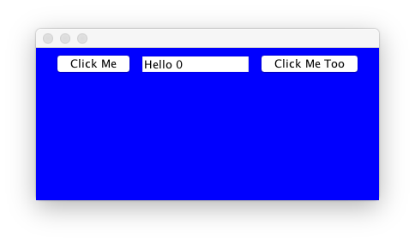

**import** java.awt.FlowLayout;

**import** java.awt.event.ActionEvent;

**import** java.awt.event.ActionListener;

**import** java.util.Set;

**import** javax.swing.JButton;

**import** javax.swing.JFrame;

**import** javax.swing.JPanel;

**import** javax.swing.JTextField;

**public** **class** JFrameExt **extends** JFrame **implements** ActionListener {

//Declare and Create GUI objects

**private** JTextField jtfMessage = **new** JTextField (10);

**private** JButton jbtClickMe = **new** JButton ("Click Me");

**private** JButton jbtClickMeToo = **new** JButton ("Click Me Too");

**private** JPanel jpMain = **new** JPanel( );

**private** **int** count = 0;

**public** JFrameExt (){

**super**();

//layout object

FlowLayout fl = **new** FlowLayout();

//make jpmain the content pain

jpMain.setLayout(fl);

//add the gui objects to the container

jpMain.add(jbtClickMe);

jpMain.add(jtfMessage);

jpMain.add(jbtClickMeToo);

jpMain.setBackground(Color.***black***);

**this**.setContentPane(jpMain);

//make the text non editable

jtfMessage.setEditable(**false**);

//register the object button with actionlistener

jbtClickMe.addActionListener(**this**);

jbtClickMeToo.addActionListener(**this**);

}

//Action Event handler method.

//jbtClickMe and jtbClickMeToo objects will call this method when clicked.

**public** **void** actionPerformed (ActionEvent e)

{

//Find out which button was clicked.

**if** (e.getSource ( ) == jbtClickMe)

{

count++;

jtfMessage.setText("Hello " + count);

}

**else** **if** (e.getSource ( ) == jbtClickMeToo)

{

count--;

jtfMessage.setText("Hello " + count);

}

}

}

**public** **class** Main {

**public** **static** **void** main (String argus[] ){

//JFrameExt object

JFrameExt f = **new** JFrameExt();

//size

f.setSize(400,200);

f.setVisible(**true**);

}

}